[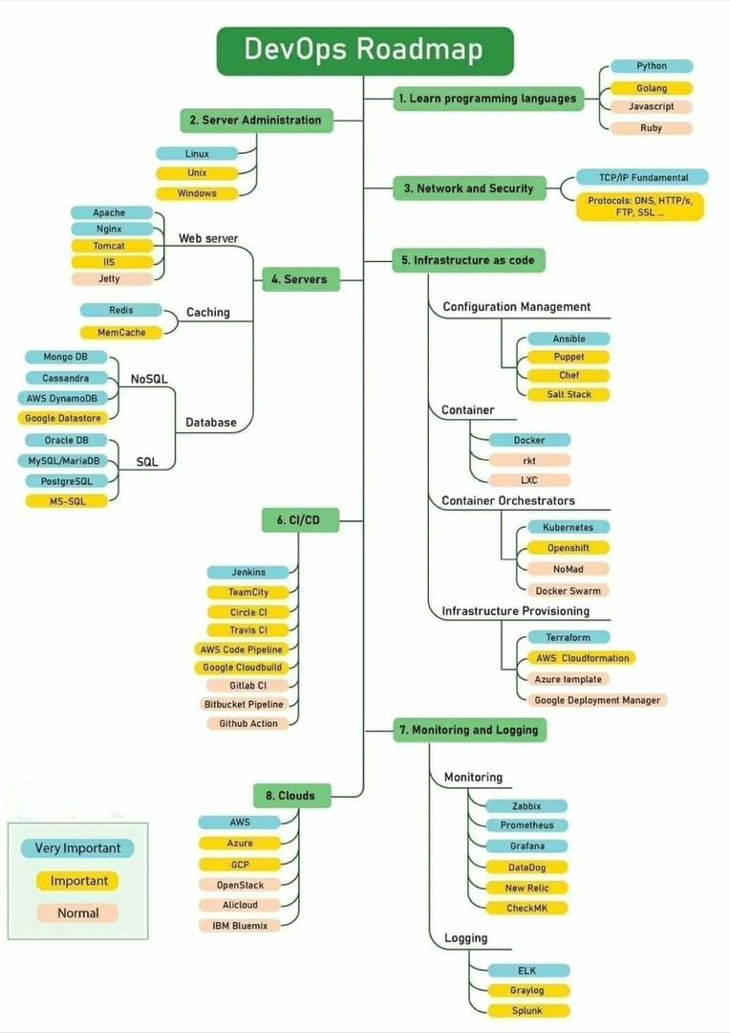](https://user-images.githubusercontent.com/85270361/212431058-b641e3fe-4aeb-4976-9d86-d89cd8fb87d6.jpg)

**Recommended RoadMap:**

Follow the Roadmap:

1. Pre-requisite

2. Networking

3. Linux

4. Shell Scripting

5. Git

6. Maven

7. Tomcat

8. Sonarqube

9. Nexus

10. Docker

11. Jenkins

12. AWS

13. Kubernetes

14. Terraform

15. Python

16. Ansible

17. Prometheus

18. Grafana

19. Projects

20. Projects Documentation on GitHub

21. Resume and LinkedIn Profile Fixing

22. Starting Applying for Jobs

[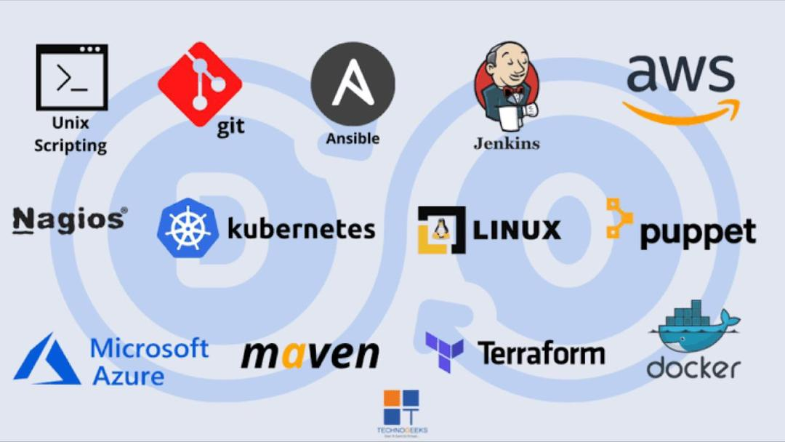](https://user-images.githubusercontent.com/85270361/213905861-91ddc00c-a15d-4286-94b1-3856f4dc853f.jpg)

**Links to Resources**

**DevOps Pre-requisite**

* [DevOps Prerequisites Course - Getting started with DevOps - FREE](https://youtu.be/Wvf0mBNGjXY)

**NETWOKING**

* [Networking Tutorial for Beginners || Computer Networking Full Course by Network Engineer. - FREE](https://youtu.be/0uflG0SemyM)
* [Networking Animated Videos - FREE](https://youtube.com/playlist?list=PL7zRJGi6nMRzg0LdsR7F3olyLGoBcIvvg)
* [DevOps - Networking knowledge base - FREE](https://youtube.com/playlist?list=PL-dQ102CNNabGpUi1oMVI85c_aGaeac7H)
* [Network Fundementals Playlists - FREE](https://www.youtube.com/playlist?list=PLDQaRcbiSnqF5U8ffMgZzS7fq1rHUI3Q8)

**Linux**

* [Introduction to Linux EDX - FREE](https://www.edx.org/course/introduction-to-linux?utm_source=aw&utm_medium=affiliate_partner&utm_content=text-link&utm_term=637513_Admitad+GmbH&awc=6798_1673649259_e8f4c73b037a5c763f3fbbbb50bbc676)
* [Linux Full Course | Linux Tutorial For Beginners | 6+ Hours of Linux FREE](https://youtu.be/8usykf7J30g)
* [Linux Administration Tutorial | Linux Tutorial | Linux Course | Intellipaat - FREE](https://www.youtube.com/watch?v=aaEoyVIowk8)
* [Linux Tutorial for Beginners: Introduction to Linux Operating System - FREE](https://youtu.be/V1y-mbWM3B8)
* [Linux Operating System - Crash Course for Beginners](https://youtu.be/ROjZy1WbCIA)
* [Linux Full Course In 5 Hours | Linux Tutorial For Beginners | Linux Training | Edureka - FREE](https://www.youtube.com/watch?v=Wgi-OfbP2Gw)
* [The Complete Linux Course: Beginner to Power User! - FREE](https://www.youtube.com/watch?v=wBp0Rb-ZJak)

**Shell Scripting**

* [Shell Scripting Crash Course - Beginner Level - FREE](https://youtu.be/v-F3YLd6oMw)
* [Shell Scripting Tutorial | Linux Tutorial | Shell Scripting Training | Intellipaat](https://youtu.be/9ckXibjManw)
* [Bash Shell Scripting Tutorial | Shell Scripting Tutorial | Learn Shell Programming - FREE](https://youtu.be/zWVV31NYi1U)
* [Shell Scripting Tutorial | Shell Scripting Crash Course | Linux Certification Training | Edureka - FREE](https://youtu.be/GtovwKDemnI)
* [Bash Tutorial: How to Use the Command Line in Linux, Windows, and Mac Terminal - FREE](https://youtu.be/BFMyUgF6I8Y)
* [Bash Scripting Full Course - FREE](https://youtu.be/e7BufAVwDiM)
* [Shell Scripting Tutorial: How to Create Shell Script in Linux/Unix - FREE](https://www.guru99.com/introduction-to-shell-scripting.html)

**Power Shell**

* [PowerShell For Beginners Full Course | PowerShell Beginner tutorial Full Course FREE](https://youtu.be/UVUd9_k9C6A)
* [Powershell Training Full Course for Beginners [Tutorial] |Windows Powershell Training FREE](https://youtu.be/bPt6DH8NYPY)
* [PowerShell Master Class - PowerShell Fundamentals FREE](https://youtu.be/sQm4zRvvX58)
* [PowerShell and Active Directory Essentials FREE](https://youtu.be/-zDXTLiX_wk)
* [PowerShell Made Easy FREE](https://youtu.be/b7SGPchYRn0)
* [Learn PowerShell in Less Than 2 Hours FREE](https://youtu.be/ZOoCaWyifmI)

**Git (version control)**

* [Git Tutorial for Beginners: Learn Git in 1 Hour - FREE](https://youtu.be/8JJ101D3knE)
* [Git Tutorial for Beginners - FREE](https://www.youtube.com/watch?v=8JJ101D3knE)
* [Git Tutorial For Beginners 2022 | Git & Github Complete Tutorial | Learn Git in 2 hrs | Simplilearn - FREE](https://youtu.be/eeuNAIZoWRU)
* [Git and GitHub for Beginners - FREE](https://www.youtube.com/watch?v=RGOj5yH7evk)
* [Git & GitHub Crash Course For Beginners - FREE](https://youtu.be/SWYqp7iY_Tc)
* [Git and GitHub for Beginners - Crash Course - FREE](https://youtu.be/RGOj5yH7evk)
* [13 Advanced (but useful) Git Techniques and Shortcuts - FREE](https://www.youtube.com/watch?v=ecK3EnyGD8o)
* [Git and GitHub Tutorial For Beginners | Full Course - FREE](https://youtu.be/3fUbBnN_H2c)
* [Git and GitHub Tutorial – Version Control for Beginners - FREE](https://www.freecodecamp.org/news/git-and-github-for-beginners/)
* [Complete Git and GitHub Tutorial - FREE](https://youtu.be/apGV9Kg7ics)
* [Git Started with GitHub - FREE](https://www.udemy.com/course/git-started-with-github/)

**webserver**

* [Web Server and Application Server | Explained - FREE](https://youtu.be/thJSev60yfg)
* [The NGINX Crash Course](https://youtu.be/7VAI73roXaY)
* [NGINX Fundamentals: High Performance Servers from Scratch](https://www.udemy.com/course/nginx-fundamentals/)
* [Maven Full Course - Learn Maven From Scratch In 2 Hours | Maven Tutorial For Beginners | Simplilearn - FREE](https://youtu.be/p0LPfK_oNCM)
* [Maven Tutorial for Beginners - 1 | Introduction to Maven | Maven Training | DevOps Tools](https://youtu.be/qkA3szVf8fg)
* [What is Apache Tomcat](https://youtube.com/playlist?list=PLzS3AYzXBoj_UYkx1Dmby3k_VZC8HQdHa)
* [web server](https://www.techtarget.com/whatis/definition/Web-server)
* [Web Servers](https://www.javatpoint.com/web-servers)

**Databases**

* [Database Systems - Cornell University Course (SQL, NoSQL, Large-Scale Data Analysis) - FREE](https://youtu.be/4cWkVbC2bNE)
* [Where's the Database in DevOps? - FREE](https://www.youtube.com/watch?v=NRqgGqm98S4)
* [DevOps for Your Relational Database Foundations - Brian Randell - NDC London - FREE](https://youtu.be/w_ZLEuo6zl4)
* [SQL Tutorial - Full Database Course for Beginners - FREE](https://youtu.be/HXV3zeQKqGY)
* [MySQL Tutorial for Beginners [Full Course] - FREE](https://www.youtube.com/watch?v=7S_tz1z_5bA)

**SonarQube**

* [What is SonarQube | Introduction SonarQube | SonarQube Tutorial | SonarQube Basics | Intellipaat - FREE](https://youtu.be/efHas35j_yg)
* [Sonarqube Tutorials - FREE](https://youtube.com/playlist?list=PLDhScTEBdP8ym3PaMkkTVuaaVHV2ktI0j)
* [Sonarqube Advance Tutorial - FREE](https://youtube.com/playlist?list=PLDhScTEBdP8zjA3867suQM59b-pEUoXVK)

**Artifact Repository Manager**

* [Nexus Repository | Nexus Repository DevOps | DevOps Tool | Intellipaat - FREE](https://youtu.be/yZFvJEygn_g)
* [Jfrog | Jfrog Artifactory | Jfrog Artifactory Tutorial | Artifactory Tutorial | Intellipaat](https://youtu.be/a1B1jXXVzPQ)

**Docker**

* [Docker Tutorial for Beginners - FREE](https://docker-curriculum.com/)
* [Docker Tutorial for Beginners - A Full DevOps Course on How to Run Applications in Containers - FREE](https://youtu.be/fqMOX6JJhGo)
* [Docker Tutorial - FREE](https://www.tutorialspoint.com/docker/index.htm)
* [Docker Tutorial for Beginners - FREE](https://youtu.be/pTFZFxd4hOI)
* [Docker Tutorial for Beginners FULL COURSE in 3 Hours - FREE](https://youtu.be/3c-iBn73dDE)
* [Docker Tutorial for Beginners - FREE](https://www.youtube.com/watch?v=3c-iBn73dDE)
* [Docker Tutorial for Beginners -FREE - Full Course - 2021](https://www.youtube.com/watch?v=p28piYY_wv8)
* [Docker Tutorial for Beginners: Basics, Architecture, Containers - FREE](https://www.guru99.com/docker-tutorial.html)
* [Docker Tutorial for Beginners - A Full DevOps Course on How to Run Applications in Containers - FREE](https://www.youtube.com/watch?v=fqMOX6JJhGo)
* [Docker Tutorial for Beginners | Docker Full Course | Access to FREE LABS - FREE](https://youtu.be/zJ6WbK9zFpI)

**Docker Swarm**

* [Docker Swarm Step by Step | What is Docker Swarm | How to create Docker Swarm | Intellipaat - FREE](https://youtu.be/74p7csxKN8M)
* [Docker Swarm Tutorial For Beginners | Docker Swarm Explained | Docker Training | Learn DevOps Easy - FREE](https://www.youtube.com/watch?v=YYfefejSgWY)
* [Docker Swarm Step-By-Step | What Is Docker Swarm | How To Create A Docker Swarm | Great Learning - FREE](https://youtu.be/W-DD3QPlRHo)
* [What is Docker Swarm: Modes, Example and Working - FREE](https://www.simplilearn.com/tutorials/docker-tutorial/docker-swarm)
* [Docker Swarm: A Complete Guide for Beginners](https://k21academy.com/docker-kubernetes/docker-swarm/)

**Jenkins**

* [Complete Jenkins Tutorial | Learn Jenkins From Scratch In 3 Hours - FREE](https://youtu.be/nCKxl7Q_20I)
* [Jenkins Full Course - Jenkins Tutorial For Beginners - Jenkins Tutorial - FREE](https://www.youtube.com/watch?v=FX322RVNGj4)
* [Learn Jenkins! Complete Jenkins Course - Zero to Hero](https://youtu.be/6YZvp2GwT0A)

**GitLab CI**

* [GitLab CI CD Tutorial for Beginners [Crash Course] - FREE](https://youtu.be/qP8kir2GUgo)
* [GitHub Actions Tutorial - Basic Concepts and CI/CD Pipeline with Docker - FREE](https://www.youtube.com/watch?v=R8_veQiYBjI)
* [DevOps with GitLab CI Course - Build Pipelines and Deploy to AWS - FREE](https://youtu.be/PGyhBwLyK2U)
* [GITLAB CI CD FULL COURSE IN 3 HOURS | Gitlab CI CD From Zero To Hero - FREE](https://youtu.be/Typ9U6k6g5s)

**Team City**

* [TeamCity | TeamCity Tutorial for Beginners | TeamCity Build Steps | DevOps Tools | Intellipaat - FREE](https://youtu.be/Q_oandwGYfk)
* [Getting Started With Kotlin DSL in TeamCity: From Zero to Hero - TeamCity Technology Day - FREE](https://youtu.be/AEYjAnR2-MY)
* [TeamCity Fundamental Tutorial for Beginners with Demo | DevOpsSchool - FREE](https://youtu.be/OCnbC7wtXys)

**SSH**

* Mobaxterm [How To SSH into EC2 Instance Using MobaXterm | AWS - FREE](https://youtu.be/hUoYVZlioRc) [How to connect to ec2 instance using mobaxterm? - FREE](https://youtu.be/EqKeoBfJGhA)
* Putty [How to Install PuTTY on Windows + SSH Connections Using PuTTY on Windows - FREE](https://youtu.be/umFEuHWJW3w) [How to Use Putty to SSH on Windows - FREE](https://youtu.be/pWDHUlvcAsg)

**Amazon Web Services (AWS)**

* [AWS Certified Cloud Practitioner Training 2020 - Full Course - FREE](https://www.youtube.com/watch?v=3hLmDS179YE)
* [AWS Digital Courses by Jon Bonso (FREE)](https://portal.tutorialsdojo.com/product-category/aws/aws-digital-courses-2/)
* [AWS Tutorial For Beginners | AWS Full Course - Learn AWS In 10 Hours | AWS Training | Edureka](https://youtu.be/k1RI5locZE4)
* [AWS Certified Cloud Practitioner Training 2020 - Full Course - FREE](https://www.youtube.com/watch?v=3hLmDS179YE)
* [AWS Certified Solutions Architect - Associate 2020 (PASS THE EXAM!) - FREE](https://youtu.be/Ia-UEYYR44s)
* [AWS Certified Solutions Architect - Associate 2020 - FREE](https://www.youtube.com/watch?v=Ia-UEYYR44s)
* [AWS Certified Developer - Associate 2020 - FREE](https://www.youtube.com/watch?v=RrKRN9zRBWs)
* [AWS Tutorial For Beginners | AWS Full Course - Learn AWS In 10 Hours | AWS Training | Edureka - FREE](https://youtu.be/k1RI5locZE4)

**Yaml**

* [YAML Tutorial for Beginners: Learn YAML in-depth for DevOps -FREE](https://youtu.be/GOk4IoYhM9U)
* [YAML - Basics - FREE](https://www.tutorialspoint.com/yaml/yaml_basics.htm)
* [YAML - FREE](https://www.freecodecamp.org/news/what-is-yaml-the-yml-file-format/)
* [YAML Tutorial: Everything You Need to Get Started in Minutes - FREE](https://www.cloudbees.com/blog/yaml-tutorial-everything-you-need-get-started)
* [Complete YAML Course - Beginner to Advanced for DevOps and more! - FREE](https://youtu.be/IA90BTozdow)

**Kubernetes**

* [Kubernetes Tutorial - FREE](https://www.tutorialspoint.com/kubernetes/index.htm)
* [Kubernetes Tutorial for Beginners: Basics, Features, Architecture - FREE](https://www.guru99.com/kubernetes-tutorial.html)
* [Kubernetes Certified Administrator resource by Walid Shaari - FREE - CKA](https://github.com/walidshaari/Kubernetes-Certified-Administrator)
* [Kubernetes Tutorial for Beginners [FULL COURSE in 4 Hours] - FREE](https://youtu.be/X48VuDVv0do)
* [Kubernetes Tutorial for Beginners - K8s - FREE](https://www.youtube.com/watch?v=X48VuDVv0do)
* [Kubernetes Tutorials For Beginners: 39 Comprehensive Guides - FREE](https://devopscube.com/kubernetes-tutorials-beginners/)
* [Certified Kubernetes Security Specialist Rescource by Walid Shaari - FREE - CKS](https://github.com/walidshaari/Certified-Kubernetes-Security-Specialist)
* [Kubernetes & Istio Service Mesh - FREE](https://www.youtube.com/playlist?list=PL34sAs7_26wPkw9g-5NQPP_rHVzApGpKP)

**Helm**

* [What is Helm in Kubernetes? Helm and Helm Charts explained | Kubernetes Tutorial 23 - FREE](https://youtu.be/-ykwb1d0DXU)
* [Creating your first Helm chart - FREE](https://youtu.be/3GPpm2nZb2s)
* [Creating your first Helm chart - Package management for K8s - FREE](https://www.youtube.com/watch?v=3GPpm2nZb2s)
* [What is Helm? - FREE](https://youtu.be/fy8SHvNZGeE)
* [What is Helm? | Helm Concepts Explained | KodeKloud -FREE](https://youtu.be/kJscDZfHXrQ)

**Managed containers (EKS/AKS/GKE)**

* [Introduction To Azure Kubernetes Service (AKS) | Azure Container Service | Azure Training | Edureka - FREE](https://youtu.be/o5qkgsyfRao)
* [AWS Kubernetes Tutorial | AWS EKS Tutorial | Kubernetes on AWS - FREE](https://youtu.be/U3SowMbnqBw)
* [Deploy to Azure Kubernetes (AKS) from Azure DevOps with Azure Pipelines | Build LIVE with Me - FREE](https://youtu.be/4Oa5HneTuKs)
* [AWS EKS Tutorial | Kubernetes on AWS | Create EKS Step by Step for Beginners | K21Academy - FREE](https://youtu.be/DcnviAwmzM4)
* [How to create AKS Cluster | Setting Up & Deploying an Azure Kubernetes Service Cluster | K21Academy - FREE](https://youtu.be/NnwQZyi0BAs)
* [Google Kubernetes Engine Tutorial | Kubernetes and Google Container Engine | Intellipaat -FREE](https://youtu.be/R_LaWVUo7Z4)

**Terraform**

* [Learn DevOps: Infrastructure Automation With Terraform -PAID](https://www.udemy.com/course/learn-devops-infrastructure-automation-with-terraform/)
* [Terraform Course - Automate your AWS cloud infrastructure - FREE](https://www.youtube.com/watch?v=SLB_c_ayRMo)
* [Terraform on AWS EKS Kubernetes IaC SRE- 50 Real-World Demos -PAID](https://www.udemy.com/course/terraform-on-aws-eks-kubernetes-iac-sre-50-real-world-demos/)
* [Terraform for DevOps Beginners + Labs: Complete Step by Step Guide - FREE](https://www.youtube.com/watch?v=YcJ9IeukJL8)
* [HashiCorp Certified: Terraform Associate 2021 - PAID](https://www.udemy.com/course/terraform-beginner-to-advanced/)
* [HashiCorp Terraform Associate Certification Course - FREE](https://www.youtube.com/watch?v=V4waklkBC38)
* [Terraform & IaC Bootcamp 2023 - PAID](https://www.udemy.com/course/terraform-iac-bootcamp/)
* [Azure DevOps: Provision API Infrastructure using Terraform - Full Course - FREE](https://www.youtube.com/watch?v=Ff0DoAmpv6w&t=6032s)
* [Infrastrcuture as Code - Playlist - FREE](https://www.youtube.com/playlist?list=PLedHPfK7UwDJdS7zTgJv8PWR9UBcPbgUO)

**Python**

* [Python Tutorial - Python Full Course for Beginners - FREE](https://youtu.be/_uQrJ0TkZlc)
* [Learn Python - Full Course for Beginners [Tutorial] - FREE](https://youtu.be/rfscVS0vtbw)
* [Python Tutorial for Beginners - Learn Python in 5 Hours [FULL COURSE] - FREE](https://youtu.be/t8pPdKYpowI)
* [Python for Everybody - Full University Python Course - FREE](https://youtu.be/8DvywoWv6fI)
* [Learn Python - Full Course for Beginners Tutorial - FREE - RECOMMENDED](https://www.youtube.com/watch?v=rfscVS0vtbw)
* [Python Tutorial for Beginners - Learn Python in 5 Hours FULL COURSE - FREE](https://www.youtube.com/watch?v=t8pPdKYpowI)
* [Python Crash Course: A Hands-On, Project-Based Introduction to Programming](https://www.amazon.com/Python-Crash-Course-Hands-Project-Based/dp/1593276036)
* [Python Documentaions](https://docs.python.org/)

**JavaScript**

* [JavaScript Tutorial for Beginners: Learn JavaScript - FREE](https://www.youtube.com/watch?v=W6NZfCO5SIk)
* [Learn JavaScript - Full Course for Beginners - FREE](https://www.youtube.com/watch?v=PkZNo7MFNFg)
* [JavaScript Full Course [8 hours] | JavaScript Tutorial For Beginners | JavaScript Training | Edureka - FREE](https://youtu.be/-nEXa4oh4bc)
* [JavaScript Tutorial For Beginners - Full Course In 11 Hours | Learn JavaScript | Great Learning - FREE](https://youtu.be/g1X6b5tRvrw)
* [JavaScript Fundamentals For Beginners -FREE](https://youtu.be/vEROU2XtPR8)

**Ansible**

* [Ansible Full Course | Ansible Tutorial For Beginners | Learn Ansible Step By Step | Simplilearn - FREE](https://youtu.be/EcnqJbxBcM0)
* [Ansible 101 by jeff Geerling - FREE](https://www.youtube.com/playlist?list=PL2_OBreMn7FqZkvMYt6ATmgC0KAGGJNAN)
* [Ansible Full Course | Ansible Training | Learn Ansible for Beginners | Edureka - FREE](https://youtu.be/9Ua2b06oAr4)
* [Ansible Full Course | 34 Topics in 2 Hours | Ansible Tutorial for Beginners - FREE](https://youtu.be/Wr8zAU-0uR4)
* [Ansible Complete Tutorial | Learn Complete Ansible From Basic To Advanced Level | Nehra Classes - FREE](https://youtu.be/q8MX_ldXrt8)

**Prometheus**

* [Prometheus Tutorial | Monitoring with Prometheus And Grafana | Prometheus Grafana Tutorial | Edureka -FREE](https://youtu.be/7gW5pSM6dlU)
* [Prometheus Tutorial - Monitoring with Prometheus And Grafana - Prometheus Grafana Tutorial - FREE](https://www.youtube.com/watch?v=7gW5pSM6dlU)
* [Monitoring using Prometheus and Grafana | ADAM -FREE](https://youtu.be/cF2P9d7rBlg)
* [Prometheus MasterClass : DevOps Infra Monitoring & Alerting - FREE](https://www.udemy.com/course/prometheus-monitoring/)

**Grafana**

* [Grafana Tutorial For Beginners | Continuous Monitoring With Grafana | DevOps Training - FREE](https://youtu.be/w-c3KYKQQfs)
* [Installing Grafana on a Linux Server - FREE](https://youtu.be/xkQ7AgBwGq0)
* [Grafana Course for Beginners | Learn Grafana | Grafana Tutorials - FREE](https://youtu.be/CjABEnRg9NI)
* [Guide to Grafana 101: Getting Started With (Awesome) Visualizations - FREE](https://youtu.be/oPumWaoNw5s)
* [Setup Prometheus & Grafana Monitoring On Kubernetes Using Helm = FREE](https://youtu.be/dk2-_DbWb80)

**ELK**

* [Elasticsearch Tutorial | ELK Stack Tutorial | Intellipaat FREE](https://youtu.be/cC4GGJ0JsSE)
* [ELK Stack Tutorial For Beginners | Elastic Stack Tutorial | DevOps | Intellipaat FREE](https://youtu.be/29TwUCHILhM)
* [Elasticsearch Tutorial for Beginners FREE](https://youtu.be/kjN7mV5POXc)
* [Beginner's Crash Course to Elastic Stack - Part 1: Intro to Elasticsearch and Kibana FREE](https://youtu.be/gS_nHTWZEJ8)

**Window Server (Optional)**

* [Windows Server Administration || for Beginners - FREE](https://youtu.be/RoI9RVU_Hu0)
* [Active Directory Tutorial for Beginners - Live Training - FREE](https://youtu.be/h0QLtup0CWQ)
* [Understanding Active Directory and Group Policy - FREE](https://youtu.be/Q4I2lKHboDw)
* [Learn Windows Server 2022 (AD, DNS, GPO) Be a Great Admin! - FREE](https://www.udemy.com/course/server2022/)

**Cloud Security**

* [Cloud Security Full Course | Cloud Security Fundamentals | Cloud Security Training | Intellipaat FREE](https://youtu.be/Ijkvx1u0w6o)
* [Cloud Security Tutorial | Cloud Security Fundamentals | What is Cloud Security | Edureka FREE](https://youtu.be/0lw4KU5wHsk)
* [Introduction to Cloud Security FREE](https://youtube.com/playlist?list=PLsfnCRA9QVnSj4gbP5W1W1CXjPRhe1oE2)

**DevSecOps**

* [DevSecOps Full Course | DevSecOps Tutorial For Beginners | DevSecOps Training | Intellipaat FREE](https://youtu.be/D7Nhna43ztg)
* [Overview of DevSecOps | What is DevSecOps | DevSecOps : What, Why and How | Infosectrain FREE](https://youtu.be/KbmmYOhL4Jg)
* [DevSecOps - the What, Why & How FREE](https://youtu.be/G1l56vDDqVk)

**DevOps Certification Path Way**

TAP ⏩ [DevOps Certificate](https://devopscube.com/best-devops-certifications/)

[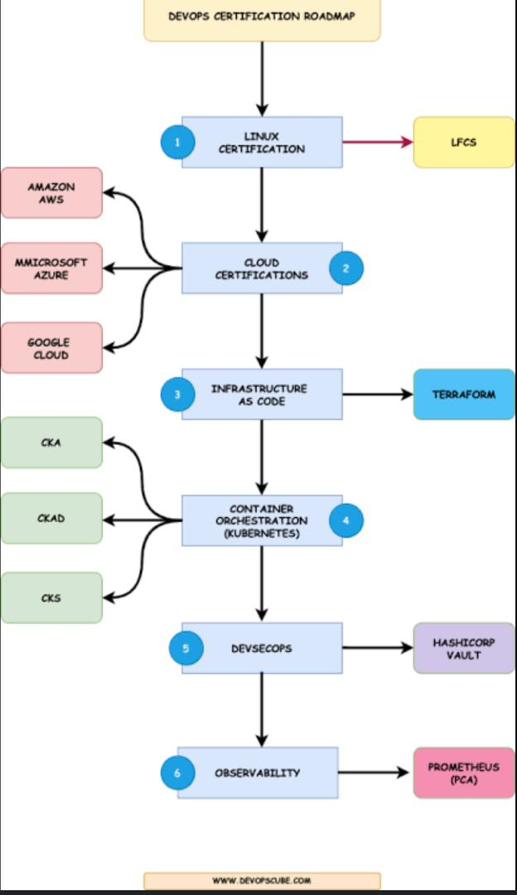](https://user-images.githubusercontent.com/85270361/212485937-b82b9821-bcf8-4366-98a5-e10e166489c1.jpg)

**Bonus**

* [CompTIA A+ Full Course - FREE - [31+ Hours]](https://youtu.be/1CZXXNKAY5o)
* [Harvard CS50 – Full Computer Science University Course](https://youtu.be/8mAITcNt710)

**How to get a Job Fast**

1. Resume : While people tend to present an essay as a resume or some template they got online 🙅‍♀

Hiring manager come across hundreds of resumes all the time, they don’t have time to read all the resumes.

First look at your resume will determine if they will go through it or not. So your resume pass through different stages before you get your first email. ⭐⭐⭐

Go through this link to understand what your resume stands against. 👇👇👇👇

[WHAT YOUR RESUME IS UP AGAINST](https://medium.com/@AnnFelix/what-your-resume-is-up-against-e6c96c1a88be)

Tips for your résumé: ✅✅✅

1. Tailor your resume to suit the position you are applying for
2. Limit your resume to two pages
3. Proofread your resume numerous times
4. Keep your resume clear and concise
5. Be honest
6. Quantify your achievements
7. Use simple words and action verbs
8. Include unpaid work that show off your skills

Resume Don’ts : ❌❌❌❌

1. Don't include a picture of yourself
2. Don't simply list job responsibilities
3. Don't include references
4. Don't include hobbies or interests
5. Don't use too many bullets
6. Don't include unnecessary personal information
7. Don't use an inappropriate email address
8. LinkedIn: Why having a good LinkedIn profile is so important these days, people don’t tend to take it serious as they should. 💁‍♀

Jobs these days require you submit your LinkedIn profile links .

LinkedIn as come to serve as a secret 🤫 background check for many companies.

Click on this link, to understand how important your LinkedIn profile is and ways to fix it. 👇👇👇👇

[Your LinkedIn account is just as important as your RESUME](https://medium.com/@AnnFelix/your-linkedin-account-is-just-as-important-as-your-resume-5435145b904f)

1. GitHub Account : Your GitHub might just be one of the place to land you your dream job. ✅

Just imagine going for a devOps or developer role and you don’t have any projects to show off . 🙅‍♀🤦‍♀

GitHub is not just about pushing codes, you can use GitHub to document your projects. ✅✅✅

Documenting your projects on GitHub can be very handy, To show off to your future employer’s and for reference purposes. ✨✨✨🤩🤩

Having many projects on your portfolio will give you an edge over someone without any projects to show off.

So make it a duty to document all your projects. ✅✅✅

Four Ace to Landing Your Dream Jobs

• Learn The Skills

• Work on Real Projects (Build Your Portfolio)

• Prep Your Resume and Your LinkedIn

• Start Applying

• Land your dream Jobs

**SITE FOR INTERVIEW PREPARATION**

* [Ambitionbox](https://www.ambitionbox.com/about-us)
* [Acetheinterview](https://www.acetheinterview.com/)
* [Gainlo](http://www.gainlo.co/#!/)

**DevOps Projects**

* [Simple DevOps Project-1 | Simple DevOps project for CI/CD | CI/CD through Jenkins - FREEE](https://youtu.be/Z9G5stlXoyg)
* [DevOps-Projects FREE](https://youtube.com/playlist?list=PLxzKY3wu0_FJdJd3IKdiM4Om1hGo2Hsdt)
* [Simple DevOps Projects - Part 1 | DevOps Projects for Beginners | DevOps Training FREE](https://youtu.be/PwSZpcl7vUE)
* [Simple DevOps Project | DevOps Projects for Beginners | DevOps Project from Scratch FREE](https://youtu.be/cnA6AwUeiHU)
* [Simple DevOps Project-2 | CI/CD pipeline using GIT, Jenkins & Ansible FREE](https://youtu.be/nE4b9mW2ym0)
* [Simple DevOps Project-3 | DevOps project with Git, Jenkins and Docker on AWS | CICD on containers - FREE](https://youtu.be/nMLQgXf8tZ0)
* [Simple DevOps Projects - Part 2 | DevOps Projects for Beginners | DevOps Training | Edureka FREE](https://youtu.be/EXdmo4OoB4Q)
* [Simple DevOps Projects - Part 3 | DevOps Projects for Beginners | DevOps Training | Edureka FREE](https://youtu.be/qEKZLZYwO9o)
* [Simple DevOps Project-4 - Part-01 | How To Create a Docker Image Using Jenkins And Ansible FREE](https://youtu.be/MJ74RcL6jv8)
* [DevOps Project 2021 - How to Learn DevOps Through a Practical Project FREE](https://youtu.be/oif22pmFMuI)
* [Simple DevOps Project - Troubleshooting steps FREE](https://youtu.be/ndo6ezzcT98)
* [Simple DevOps Project-4 - Part 03 | Enable versioning on docker images through jenkins job FREE](https://www.youtube.com/watch?v=vU7K94Pt2yQ)
* [Complete DevOps Project | Github, Docker, Dockerhub, Git, Jenkins, Ansible FREE](https://www.youtube.com/watch?v=gvk9jZz0P6s)
* [Simple DevOps Projects - Simple DevOps Projects #1 |DevOps Jenkins CI/CD project Apache Tomcat maven FREE](https://youtu.be/4TRfvlU7W90)
* [sample devops end to end project v1- devops project | ci/cd declarative pipeline using devops tools FREE](https://youtu.be/nP6uei3TBsc)
* [Complete END to END Azure DevOps Tutorials Series with Practical's Full Course in 4 Hours](https://www.youtube.com/watch?v=7YMWthE6RTY)
* [DevOps Setup for Test, Build and Deploy a Java Project | DevOps Project to Build, Test and Deploy FREE](https://youtu.be/vQRSRo7Ef7c)
* [DevOps Project Part-2 | Setting up CI-CD Pipeline for an E-Commerce App | DevOps Training | Edureka FREE](https://www.youtube.com/watch?v=3ixEo13ZdsU)
* [AWS Projects for beginners | Deploying End to End Website on AWS FREE](https://youtu.be/7Gym2XVcA5A)
* [AWS CodePipeline tutorial | Build a CI/CD Pipeline on AWS FREE](https://youtu.be/NwzJCSPSPZs)
* [DevOps Project | Creating CI CD Pipeline Using Jenkins | Intellipaat FREE](https://youtu.be/7lazzvm1ljo)
* [Mega Real-time End to End DevOps CI/CD Project | Git | Jenkins | Nexus | SonarQube | HandsOn Lab - I](https://youtu.be/Yk7k3yEguQA)
* [CICD pipeline for Java application to deploy on kubernetes cluster using Jenkins | Devops Project FREE](https://youtu.be/adG0vq5boL8)
* [Setup EKS Cluster using eksctl and Deploy Springboot Microservices into EKS using Jenkins Pipeline FREE](https://youtu.be/C1BlN66s9yo)

**AWS Certification Roadmap**

[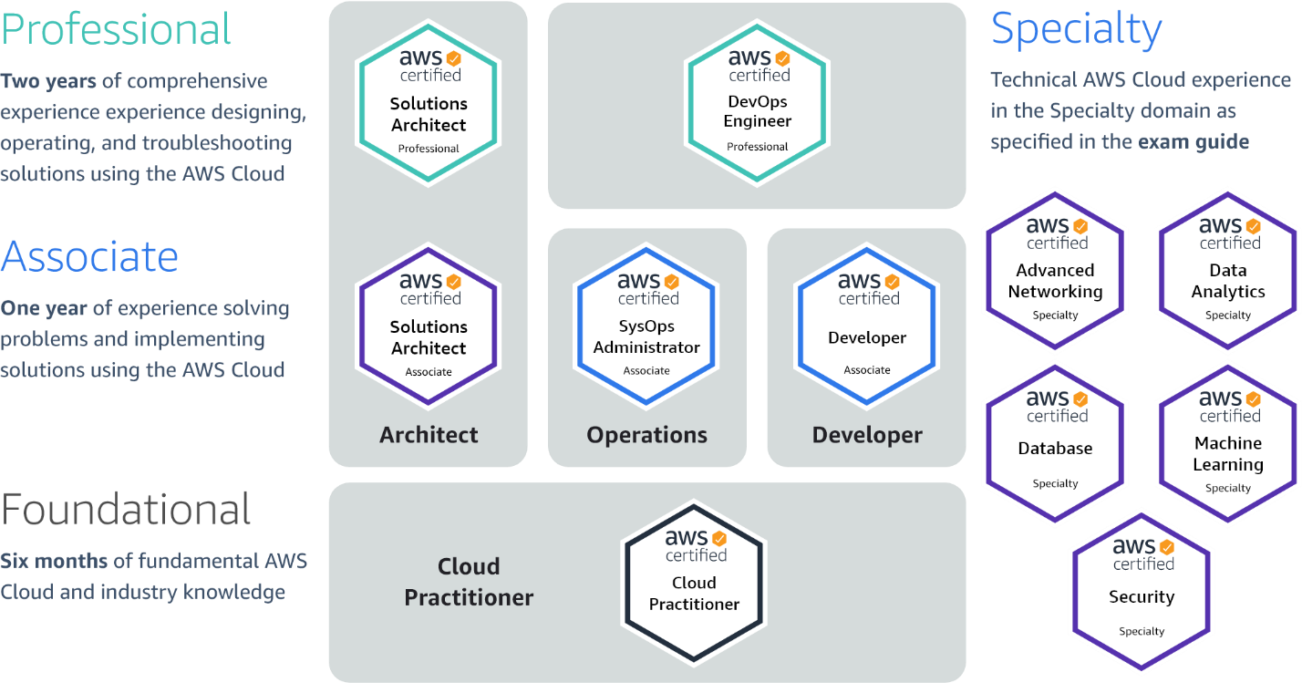](https://user-images.githubusercontent.com/85270361/213398206-e4998714-0aae-40d7-a6d0-eaa34c85bd04.png)

**List of all Amazon Exams**

**EXAM-TOPICS DUMP**

1. [ANS-C00: AWS Certified Advanced Networking - Specialty](https://www.examtopics.com/exams/amazon/ans-c00/view/)
2. [AWS Certified Alexa Skill Builder - Specialty: AWS Certified Alexa Skill Builder - Specialty](https://www.examtopics.com/exams/amazon/aws-certified-alexa-skill-builder-specialty/view/)
3. [AWS Certified Big Data - Specialty: exam](https://www.examtopics.com/exams/amazon/aws-certified-big-data-specialty/view/)
4. [AWS Certified Cloud Practitioner: AWS Certified Cloud Practitioner (CLF-C01)](https://www.examtopics.com/exams/amazon/aws-certified-cloud-practitioner/view/)
5. [AWS Certified Data Analytics - Specialty: AWS Certified Data Analytics - Specialty (DAS-C01)](https://www.examtopics.com/exams/amazon/aws-certified-data-analytics-specialty/view/)
6. [AWS Certified Database - Specialty: AWS Certified Database - Specialty](https://www.examtopics.com/exams/amazon/aws-certified-database-specialty/view/)
7. [AWS Certified Developer Associate: AWS Certified Developer Associate](https://www.examtopics.com/exams/amazon/aws-certified-developer-associate/view/)
8. [AWS Certified Machine Learning - Specialty: AWS Certified Machine Learning - Specialty (MLS-C01)](https://www.examtopics.com/exams/amazon/aws-certified-machine-learning-specialty/view/)
9. [AWS Certified SAP on AWS - Specialty PAS-C01: AWS Certified SAP on AWS - Specialty PAS-C01](https://www.examtopics.com/exams/amazon/aws-certified-sap-on-aws-specialty-pas-c01/view/)
10. [AWS Certified Security - Specialty: AWS Certified Security - Specialty](https://www.examtopics.com/exams/amazon/aws-certified-security-specialty/view/)
11. [AWS Certified Solutions Architect - Associate SAA-C02: AWS Certified Solutions Architect - Associate SAA-C02](https://www.examtopics.com/exams/amazon/aws-certified-solutions-architect-associate-saa-c02/view/)
12. [AWS Certified Solutions Architect - Associate SAA-C03: AWS Certified Solutions Architect - Associate SAA-C03](https://www.examtopics.com/exams/amazon/aws-certified-solutions-architect-associate-saa-c03/view/)
13. [AWS Certified Solutions Architect - Professional: AWS Certified Solutions Architect - Professional](https://www.examtopics.com/exams/amazon/aws-certified-solutions-architect-professional/view/)
14. [AWS Certified Solutions Architect - Professional SAP-C02: AWS Certified Solutions Architect - Professional SAP-C02](https://www.examtopics.com/exams/amazon/aws-certified-solutions-architect-professional-sap-c02/view/)
15. [AWS Certified SysOps Administrator - Associate: AWS Certified SysOps Administrator - Associate (SOA-C02)](https://www.examtopics.com/exams/amazon/aws-certified-sysops-administrator-associate/view/)
16. [AWS DevOps Engineer Professional: AWS DevOps Engineer - Professional (DOP-C01)](https://www.examtopics.com/exams/amazon/aws-devops-engineer-professional/)
17. [AWS-SysOps: AWS Certified SysOps Administrator](https://www.examtopics.com/exams/amazon/aws-sysops/view/)

**ALISON DUMP**

1. [CLF-C01:AWS Certified Cloud Practitioner](https://www.exam-answer.com/amazon/clf-c01/question1)
2. [SAA-C03:AWS Certified Solutions Architect - Associate](https://www.exam-answer.com/amazon/saa-c03/question1)
3. [SAP-C01:AWS Certified Solutions Architect - Professional](https://www.exam-answer.com/amazon/sap-c01/question1)
4. [SOA-C02:AWS Certified SysOps Administrator - Associate](https://www.exam-answer.com/amazon/soa-c02/question1)
5. [DVA-C01:AWS Certified Developer - Associate](https://www.exam-answer.com/amazon/dva-c01/question1)
6. [DOP-C01:AWS Certified DevOps Engineer - Professional](https://www.exam-answer.com/amazon/dop-c01/question1)
7. [DBS-C01:AWS Certified Database - Specialty](https://www.exam-answer.com/amazon/dbs-c01/question1)
8. [BDS-C00:AWS Certified Big Data - Specialty](https://www.exam-answer.com/amazon/bds-c00/question1)
9. [ANS-C01:AWS Certified Advanced Networking - Specialty](https://www.exam-answer.com/amazon/ans-c01/question1)
10. [SCS-C01:AWS Certified Security - Specialty](https://www.exam-answer.com/amazon/scs-c01/question1)
11. [MLS-C01:AWS Certified Machine Learning - Specialty](https://www.exam-answer.com/amazon/mls-c01/question1)